**Re-Wirement 1**

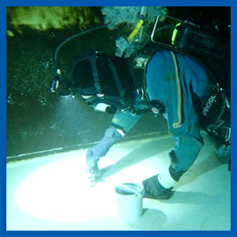

Many people spend their lives focused on work, and when this reduces or ceases altogether, it can create a vacuum that needs to be filled with other activities.  
  
Traveling is one such alternative, but this can only last so long, before a need to feel useful asserts itself again.  
  
Acting as a volunteer at water industry events can be beneficial to both the industry and the person involved.